Amanda Wedergren

April 18, 2025

Module 8.2 Assignment

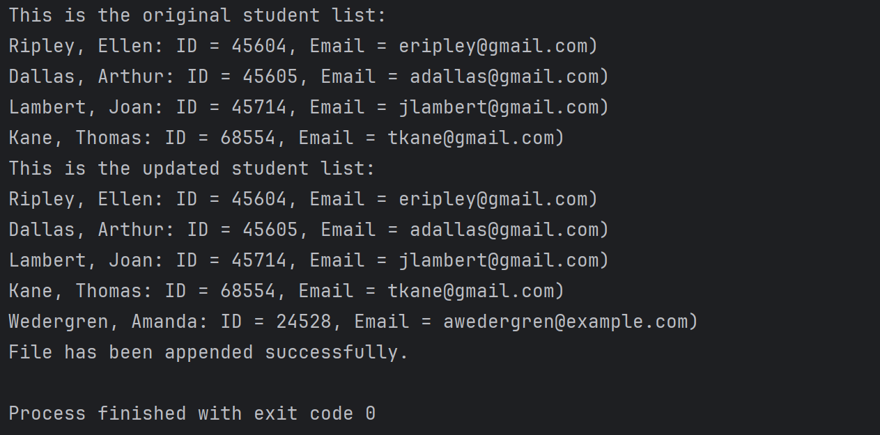

I never got a pop up box asking about saving the updated file after appending the new data. However, you can see from the next screenshot that the new student information was successfully added to the JSON file.

